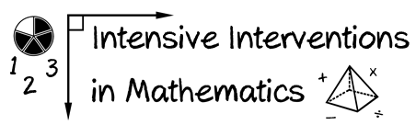
- Module 3
- Part 1
- Discussion
Share an example of an evidence-based intervention or strategy that you find useful in the classroom.
(This space is for organizing your ideas.)

