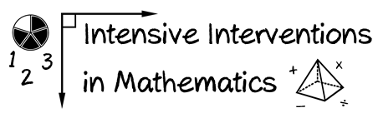
- Module 3
- Part 2
- Activity #4
Locate the following mathematics interventions. How would you rate the evidence?

(Choose two evidence-based interventions and two evidence-based strategies in mathematics for the grade level you teach.)
Name of Practice | Assessment Data to Show Results |  | Replication |  |  | Setting
 | Improvement from Before Intervention | Improvement Compared to No Treatment Students | Multiple Researchers | Multiple Students | Multiple Times | Setting and Students Similar to Your Own?
Evidence-based Intervention 1:
Evidence-based Intervention 2:
Evidence-based Strategy 1:
Evidence-based Strategy 2:
Notes/Comments:
__________________________________________________________________________________________
__________________________________________________________________________________________
__________________________________________________________________________________________

