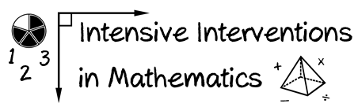
- Module 3
- Part 1
- Activity #1
Look at the examples of different evidence-based practices. Is each an evidence-based intervention, an evidence-based strategy, or a promising practice?
Name of Practice | Description | EBI | EBS | PP
Number Rockets | A tutoring program covering first grade math skills.
Explicit Instruction | A structured instructional method that includes techniques like modeling, scaffolding, breaking difficult tasks into smaller steps, etc.
Taped Problems | Students are presented with a set of number combination, then listen to then on an audio-recording that includes a brief pause after each problem and then the correct answer. The students’ goal is to write down the correct response before the recording states the answer.
Roots | 50 lessons targeting number sense skills for kindergarteners.
Word Problem Mnemonics | Memory devices that remind students of steps required to solve a word problem.
Incremental Rehearsal | Using flashcards, student works on approximately equal numbers of known and unknown facts. Student targets the unknown facts with increasing numbers of known facts between reviews.
Schema-based Instruction | When solving word problems, students identify a problem type, then use a diagram or an equation to solve the problem.
Concrete-Representational-Abstract (CRA) | Students are taught mathematics concepts using concrete materials, pictorial representations, and symbolic notation, to facilitate the understanding of mathematical procedures.
Pirate Math | A schema-based word-problem tutoring program for 2nd and 3rd grade students. Students use schemas to analyze addition and subtraction word-problems, then write equations with an “X” representing the missing information, and solve for “X.”
Note: EBI = evidence-based intervention; EBP = evidence-based strategy; PP = promising practice
Notes/Comments: ___________________________________________________________________________________

__________________________________________________________________________________________________

__________________________________________________________________________________________________

__________________________________________________________________________________________________

__________________________________________________________________________________________________

