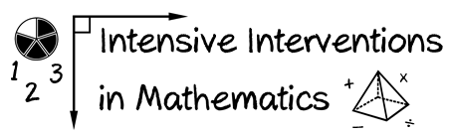
- Module 2
- Part 3
- Discussion
Share your current structure for making DBI decisions.
- Who administers progress monitoring measures?
- Who makes the decisions about response?
- When and how are decisions made?

Write an original post on the Discussion Board and respond to two peers.
(This space is for organizing your ideas.)

