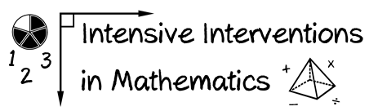
- Module 2
- Part 1
- Activity #2
Look at the sample diagnostic assessment score report.
- What are the student’s strengths?
- What are the student’s weaknesses?
Diagnostic Score Report for 4th grader Tyler Johns (MOY):
Subtest | Raw Score | Standard Score | Grade Equivalency
Whole Number Operations | 35 | 80 | 3.3
Addition and Subtraction | 17 | 82 | 3.5
Multiplication and Division | 13 | 78 | 2.9
Comparisons | 5 | 85 | 3.5
Algebraic Thinking | 12 | 69 | 1.9
Rational Numbers | 37 | 73 | 2.5
Addition and Subtraction | 13 | 73 | 2.5
Multiplication and Division | 15 | 75 | 2.7
Comparisons | 9 | 71 | 2.1
Geometry | 18 | 84 | 3.8
Data and Measurement | 18 | 85 | 3.6
Problem Solving | 22 | 72 | 2.6
Concepts | 12 | 73 | 2.5
Applications | 10 | 71 | 2.2

Strengths: ____________________________________________________________________________________________________________________________________________________________________________________________________________________________________________________________________________________________________________________
Weaknesses:_________________________________________________________________________________________________________________________________________________________________________________________________________________________________________________________________________________________________________

