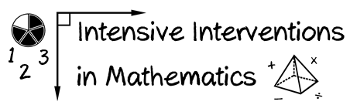
- Module 1
- Part 3
- Activity #5

Look at this set of word problems used in a third-grade intervention:
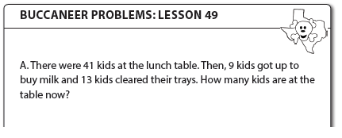

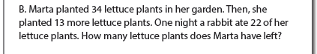

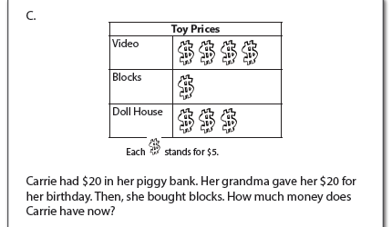

- What foundational skills do students need to know in order to successfully solve such problems?

- What types of assessments would you use to design the mathematical content for intensive intervention?

