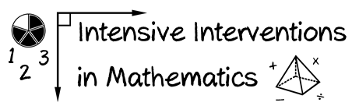
- Module 1
- Part 2
- Activity #4

Determine the foundational skills that may need to be included within intensive intervention. You can use your state standards or your knowledge of mathematical pathways.

Where student NEEDS TO BE
Where student IS

Solve problems involving four operations
Use equivalent fractions as a strategy to add and subtract fractions

Continuum of mathematics learning

