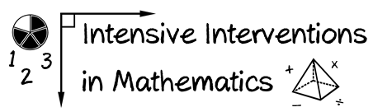
- Module 1
- Part 2
- Activity #2

Place the operations content in order from easier skills to more difficult skills.
(Number from 1-8.)
Explain why addition and subtraction strategies work, using place value and the properties of operations.
______
Apply properties of operations as strategies to add, subtract, factor, and expand linear expressions with rational coefficients.

______
Add, subtract, multiply, and divide decimals to hundredths, using concrete models or drawings and strategies based on place value, properties of operations, and/or the relationship between addition and subtraction.

______
Apply the properties of operations to generate equivalent expressions.
______
Solve linear equations with rational number coefficients, including equations whose solutions require expanding expressions using the distributive property and collecting like terms.
______
Apply properties of operations as strategies to multiply and divide.
______
Find whole number quotients and remainders with up to four-digit dividends and one-digit divisors, using strategies based on place value, the properties of operations, and/or the relationship between multiplication and division.
______
Apply properties of operations as strategies to add and subtract.

______

