Activity 5.24 – I’ll Start It…
Apply your Knowledge
Workbook
The lesson will be a curriculum example. It is a beginning reading lesson. Read the curriculum example below.
Objective: to understand relationships between letters and sounds
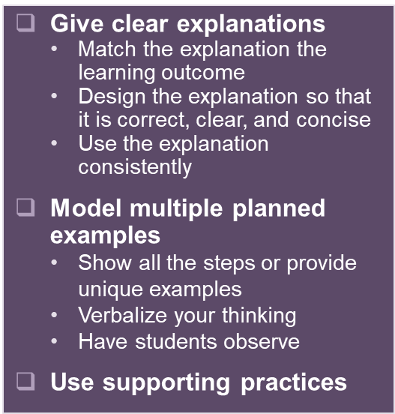
Curriculum Example

Have children name the pets in the illustration that goes with the poem. Elicit the word dog and write it on the board. Tell the children that they will learn about the sound they hear at the beginning of dog and the letter that stands for that sound.

Ask children to read the first line of the poem. Have them find dog and match it with the word dog on the board. Then have children read the following pairs of words. Ask them to repeat each pair of words and tell them which word in the pair begins with the same beginning sound as dog: dig, jig, dime, rhyme, date, gate, fill, dill, rug, dug

Call attention to the word dog on the board. Ask children to name the letter that stands for the sound they hear at the beginning of dog. A volunteer can draw a line under the letter d.

Does the objective work?

Watch the module to see how Devin begins the explanation and model. Continue the explanation and write two more cycles of modeling below.
Objective: Students will identify spoken words that begin with the /d/ sound and associate them with the letter d.
Cycle 1
Explanation
We already know this letter. What letter? d. We also know the sound of d. What is it? /d/. We are going to listen to the first sound in words and

Model
My turn first. Hold up dog picture. This says dog. What does it say? Dog. Now, I

Cycle 2
Explanation

Model

Cycle 2
Explanation

Model

.

