

Activity 5.22 – Stop & Jot

*Solidify your Understanding*

Workbook

Objective: you will be able to tie a necktie using a simple knot.

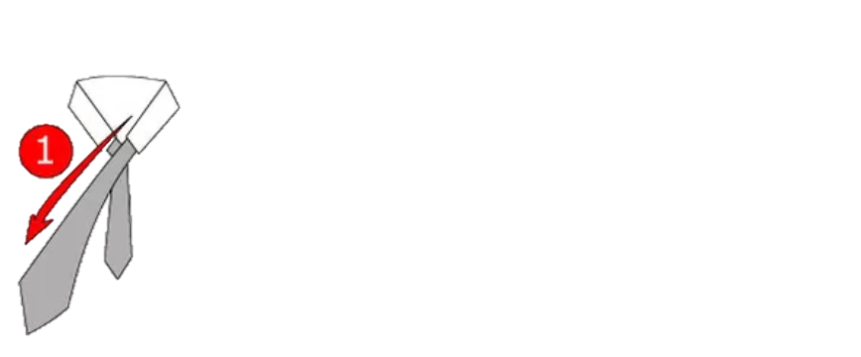step two and three of tying a tie
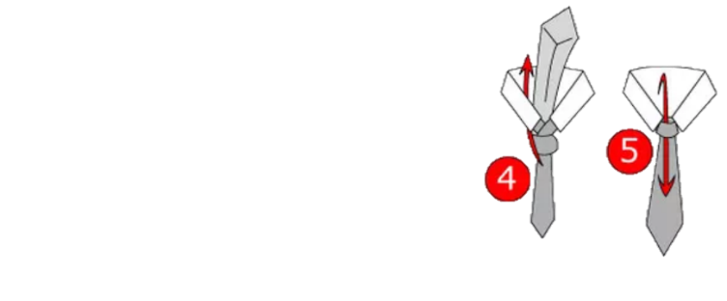

1. Drape the tie around your neck with the seam-side hidden. Cross the ends with the narrow end behind the wide one. Make sure the wide end hangs longer.

4. Pull the wide end up through the back. Then, slide the wide end between the front part of the loop and the short end of the tie.

5. Pull it down to finish the knot.

2. Loop the wide end around the back of the narrow end.

3. Keep looping the wide end so it crosses the front and goes to the back again.

What was effective about the explanation?

Would you be ready to practice? Explain.