****

Activity 5.2 – Stop & Jot

*Solidify your Understanding*

Workbook

The glass bowl (vase) represents a student who needs

The earthenware bowl represents a student with

The stone represents

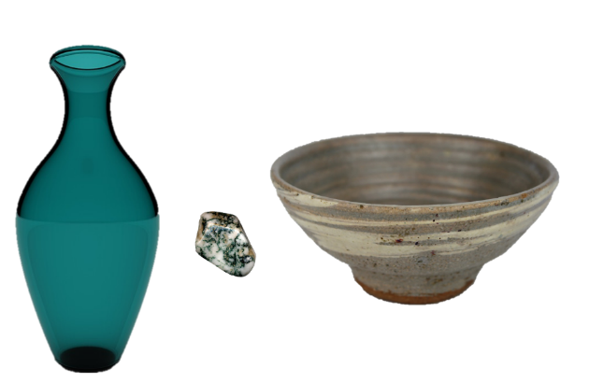

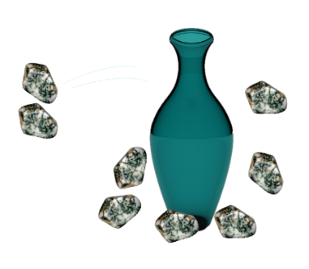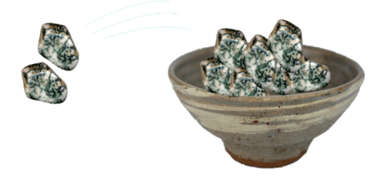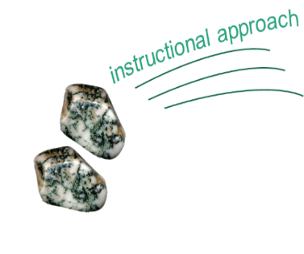

Why does the same instructional approach produce such different academic outcomes for each type of student?

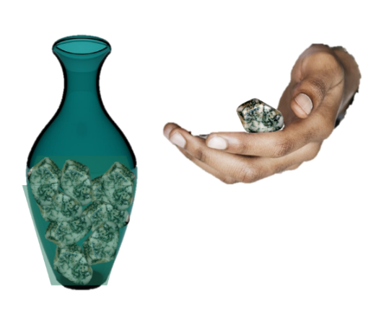

How is explicit instruction different from other ways of providing instruction? Why does it work so well for students who need intensive intervention?