**Activity 8.3 –Discussion Board**

***Effective Teacher Behaviors***

***Online***

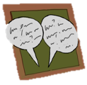

Please complete a discussion board post that answers the following questions. Once you’ve posted, please respond to at least two of your classmates’ posts by offering feedback and additional ideas for replacement behaviors.

* Develop a competing behavior pathway for Jessica.

Use the space below to jot down your ideas before posting.

**A graphic used to develop a competing behavior pathway for Jessica. **