Module 3 Quiz

Matching Classroom Expectations: Please place the terms in the left column with the appropriate box in the graphic on the right.

Evaluate | 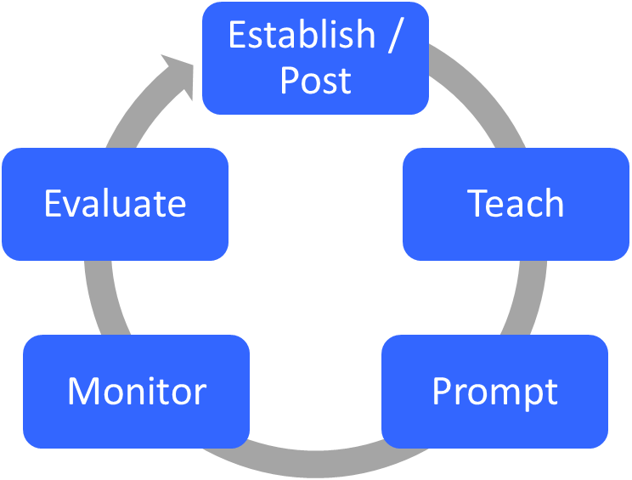  4.  3.  2.  1.  5.
Prompt
Monitor
Establish/Post
Teach

True or False

The following strategies are PROACTIVE (antecedent) strategies:
- Maximize structure ________________
- Brief, specific, and contingent error corrections ________________
- Increasing student opportunities to respond ________________
- Establish, Post, and Teach behavioral expectations ________________
- Active supervision includes ALL of the following: moving around, looking around, scanning, and interacting with students. ________________
- To evaluate if your instruction was effective (i.e., resulted in behavior change) you should ask the students if they liked the lesson. ________________

Classroom expectations should be all of the following EXCEPT:
- Positively stated _________________
- Applicable to a limited number of settings _________________
- Mutually exclusive _________________
- Easy to remember _________________

