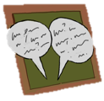
Activity 2.4 – Discussion Board
Prompting & Stimulus Control
Online

Before you complete this module, please complete a discussion board post that answers the following questions. Once you've posted, please respond to at least two of your classmates' posts.

- Describe a situation in which you want to establish stimulus control. Describe how you would establish stimulus control.
- How would you use and fade prompts?

You may use the space below to draft a copy of your response before posting a copy online.

__________________________________________________________________________________________________________________________________________________________________________________________________________________________________________________________________________________________________________________________________________

