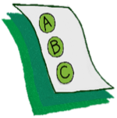
Activity 1.8 – Quiz
What’s the consequence?
Workbook

Look at the items below. Underline the consequence in each item.

- After the students lined up, they were allowed to go to recess.
- After the teacher yelled at the class they were quiet.
- When she hit, she felt bad.
- After the students put away their lab materials, they were allowed to leave for lunch.
- After the student ripped up his paper, the teacher walked away.

