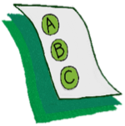
Activity 1.6 – Quiz
Which one is NOT a behavior?
Workbook

Look at the following rows. Circle the one in each row that is NOT a behavior.

- Hits Spits Angry Bites

- Hurts Cries Slaps Whines

- Smiles Laughs Wiggles Happy

