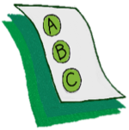
Activity 1.5 – Quiz
What’s the “antecedent”?
Workbook

Look at the following scenarios. Underline the antecedent.

- The teacher said, “line up”, and the students pushed their chairs and made a line at the door.
- The teacher said, “put your books away”, and the students put their books back in their backpack.
- When he was given a difficult math assignment, he put his head down and refused to begin the work.
- The principal entered the room to observe math instruction, and the teacher provided more opportunities to respond.
- She felt mad, so she hit.

