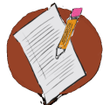
Activity 5.1 – Stop & Jot
Develop Brief Error Corrections
Workbook

- Write three (or more) specific brief error correction statements that you will use to correct inappropriate social behavior.

- If you have extra time, consider how you would modify those statements based on students’ learning histories, age, etc.

Error Correction Statement #1

Optional: Modification for Error Correction Statement #1:

Error Correction Statement #2

Optional: Modification for Error Correction Statement #2:

Error Correction Statement #3

Optional: Modification for Error Correction Statement #3:

